Review Scene : John Fleming’s “James Taylor: Bittersweet and Low” 12th November, 2015

Posted on November 16, 2015 by Anna-Maria Megalogenis in Gig Scene, Review Scene

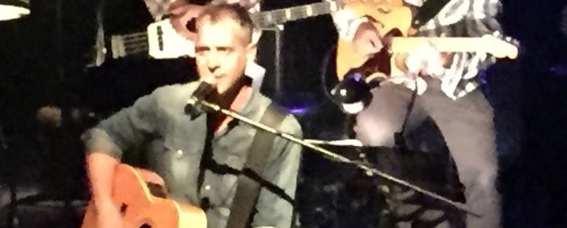

In the musty confines of one of the intimate performance spaces in Chapel off Chapel, John Fleming narrates the story and performs the music of James Taylor in a loving tribute to Taylor’s brilliant legacy. James Taylor– Bittersweet and Low 2-part 90 minute show is a chronological map of Taylor’s life, his prolific musical career, relationships, struggle with heroin addiction, depression, anxiety and his psychiatric hospital stays, all imbued with a sense of hope. The show centres on the early years of his career, from 1965-1977. Given that 67 year old James Taylor finally kicked his drug habit in 1983, and continues to write and perform music until today, there is a happy ending in store, which picks up where the show ends.
John Fleming narrates the story, he wrote and produced, with clear conviction and pathos. Songs are woven seamlessly throughout the production representing crucial points in James Taylor’s life and career. “Fire and Rain” his first hit, on his second album Sweet Baby James was written in response to his childhood friend Suzanne Schnerr’s suicide and his own struggle to overcome drug addiction and depression. Fleming’s rendition of the song with the assistance of Gavin Gray on drums, Doug Robertson on bass, Bruce Haynes on piano and Lisa Hanley on backing vocals is performed with aplomb.
Taylor was diagnosed as suicidal before he finished high school, and sought treatment throughout life. His lyrics were often a reflection of his struggles and life experiences. The song “Sweet Baby James” was inspired by his nephew James, and is one of many fine songs performed tonight. Taylor was also romantically involved with folk singer Joni Mitchell, the romance aptly depicted in the show as a duet between multi-talented Lisa Hanley and John Fleming as they sing “That Song About the Midway” in their 1970 Royal Albert Hall performance. Hanley’s awe inspiring vocal gymnastics are displayed to full effect when performing the songs and part of Carole King. “Natural Woman” and I Feel the Earth Move” are searing highlights.

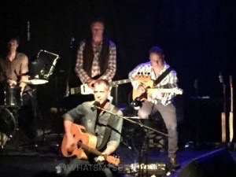

Carole King formed a close friendship with Taylor and also wrote one of his biggest hits “You’ve Got a Friend,” another gem sung by Fleming, and performed by the band with backing vocals courtesy of Hanley and Robertson. In 1972 James Taylor married fellow musician Carly Simon, and the pairing produced many songs written for one another and often performed together prompting an entertaining rendition of “Mockingbird” by Hanley and Fleming.
A stirring harmony between Fleming, Henley and Robertson during “You Can Close Your Eyes” at the shows conclusion is the most moving song of the set, and also the song which resonates most strongly with Fleming.
Fleming’s “James Taylor- Bittersweet and Low” took the audience on an honest musical and personal journey through James Taylor’s life, woven with his beautifully constructed and lyrically potent songs, performed with passion and precision by Fleming and his talented group of musicians. A must see for theatre goers and music fans.

