James Taylor: Sweet and Low at Chapel Off Chapel

by Elizabeth Quinn

Chapel Off Chapel is a gem of a live theatre venue in Little Chapel St Prahran. Encircled by the peaceful green space of Princes Gardens, the light and airy interior of the building provides a stark contrast to the frenetic pace of Chapel Street.

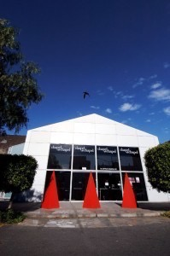
Chapel Off Chapel Entrance

Prop at the bar for a pre-show or intermission gargle. And no need to knock back that half glass of shiraz when you hear the bell ring - you can take it in to the theatre with you. No plastic goblets here - at Chapel Off Chapel you're treated like a grown up. So refreshing.

It's a venue that isn't afraid to take risks, and one of the few theatres prepared to take an unpolished diamond and give it the opportunity to shine. James Taylor; Sweet and Low is one such diamond.

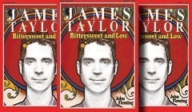

It's the product of two years' work by John Fleming of the Scared Weird Little Guys and focuses on Taylor's early career, both musical and romantic, up until his signing with Columbia Records in 1976 after a 7 year stint with Warner Records.
John Fleming
large image

James Taylor's life is told mainly in song, interspersed with minimal narration. All the old favourites are there, along with an interesting mix of lesser known songs, some unrecognised by your reviewer. Luckily for her, she had the southern hemisphere's JT trivia champion seated next to her to fill in the gaps, and their inclusion added another interesting dimension to the story.

John Fleming's backing band was clearly there for their musical abilities rather than their stage presence, with one luminous exception: Lisa Hanley took on the challenge of portraying both Joni Mitchell and Carli Simon in both voice and musicianship. And won. Her guitar and piano performances were close to faultless, as was her beautiful portrayal of two very different but exceptional singing styles.

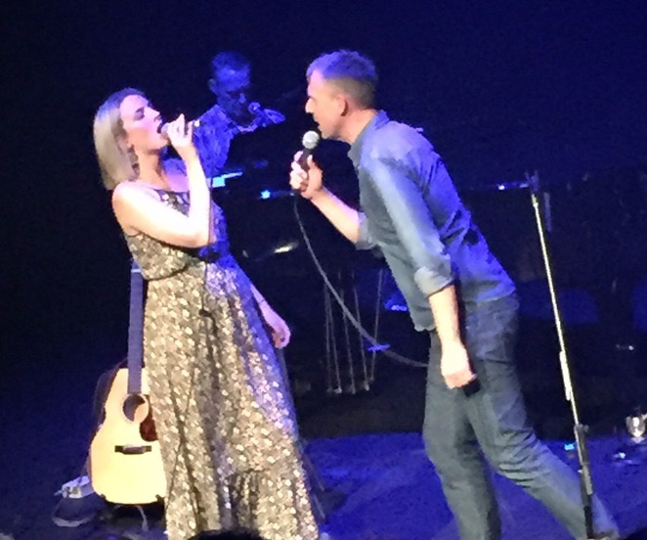
Lisa Hanley and John Fleming
large image

James Taylor: Sweet and Low deserves an audience and will appeal to those JT tragics like my Plus One who look forward with unrealistic expectation to the anticipated tour of their idol after the release earlier this year of his album Before The World. The show has a very short season so Don't Let Yourself Be Lonely Tonight. You've Got a Friend at Chapel off Chapel for the next two days.

